SEISMIC BEHAVIOR OF EL-FERDAN RAILWAY BRIDGE

###### A. M. ABOU-RAYAN

###### *Associate Professor and Head of the Civil Engineering Technology Department*

*High Institute of Technology, Benha University, 13512, Egypt*

**ABSTRACT**

Bridges are indispensable components of the infrastructure of modern society, and their assessment via techniques of structural dynamics is assuming greater importance. Seismic responses of EL-Ferdan Railway Bridge (over the Suez Canal near Ismalia city) were investigated through three-dimensional finite-element model. The Seismic analyses have been conducted from the deformed configuration due to the bridge own-weight for two cases of operation, the open position and closed position. The earthquake records were input in the bridge longitudinal, lateral, and vertical directions simultaneously. Results include dynamic characteristics, time-history, and frequency –domain responses.

**INTRODUCTION**

The development of the Sinai Peninsula in Egypt, become one of the most promising projects in Egypt. To achieve this goal, it is important to provide links between the main land and the Sinai Peninsula across the Suez Canal .Although there are different transportation ways to cross the Suez Canal, via: Ahmed Hamedy tunnel, Ferrboats and the peace bridge at Qantara city, still the most important one is El-Ferdan Railway Bridge. El-Ferdan Railway Bridge was built five times at the same location, because of the continuing of widening and Deeping of the Suez Canal, since it is the most important man-made shipping channels in the word. The fifth one was completed in 2001. Table 1, gives a brief description on the history of EL-Ferdan Bridge, Taha and Buckby [1].

EL-Ferdan Bridge is considered to be the longest span swing bridge in the world, 640 m in length and 9.2 m in width with towers height of 60.6 m. This bridge provides alternate crossing for a single – track railway. The entire bridge structure is based on two identical swing bridges. Each swing bridge has a weight of approximately 5000 tons and cantilever girders of 170 m and 150 m in length, where the longer of the two cantilever girders is swung across the Canal. On other word, the bridge statical system is composed of two double cantilevers each unit is supported on roller bearing on land side and roller bearings base mounted on pile cap from the Canal side (longer cantilever side). The bridge was designed by a consortium of Egyptian and European engineering companies, led by Krupp of Germany in joint venture with basics of Belguim and orascom of Egypt***.*** For more details of the bridge, the reader is referred to Taha [1] and schlecht [2].

The objective of this study is to obtain a comprehensive understanding of the dynamic characteristics of the recently completed double-span swing bridge, EL-Ferdan Bridge. Also, this paper emphasizes the importance of performing dynamic time-history analysis to evaluate the overall performance under the effect of several ground motion.

**TCHENICAL FEATURES OF EL – FERDAN RAILWAY BRIDGE**

Generally, in the case of truss girder bridge system, the towers are rigidly connected to the deck, which is the present case under study. Towers and the bridge deck are considered to be one structural unit. Therefore, the bridge statical system is composed of two separate structural units; 1) towers and deck, 2) piers. This statical system is completely different than that of the Suez-Canal cable-stayed bridge. Where, the steel deck is rested on pylons (tower and pier are one structural unit) cross beams by means of rubber bearing and other supports [3]. The main technical data of the bridge are as follows:

***Pylon***

The pylon as well as most of the remaining truss walls consists of fully welded box sections. Only the short posts and the tensions diagonals at the bridge ends are designed as open sections.

***Deck and truss members***

The longitudinal stiffening of the road deck is achieved by cold formed trapezoidal stiffeners. Underneath the rail tracks built-up sections are in addition. The curved form of the upper chord results in forces analogues to those in cable stayed bridge. in addition deck with two vertical truss walls and horizontal bracing in the upper chord level form a huge box section with high torsion stiffness.

***Electro mechanical slewing******system***

The main electro-mechanical items are the two slewing systems underneath the pylon and the locking systems in the bridge ends. Each slewing system consists of a roller bearing base, concreted in the pile cap. A roller bearing assembly with 112 conical roller, and the ring girder are on the top of the roller bearing. A pivot pin with a length of 3.2 m and a diameter of 1.3 m is situated to facilitate rotation. Spokes connect the pivot pin with the roller bearing and the ring girder.

**FINITE ELEMENT MODAL**

The bridge is discretized as a three dimensional finite element modal which includes three types of elements; frame, shell and link members to simulate the bridge locking system. Next, towers have been modeled as a three dimensional frame elements. The material behavior is linearly elastic and the damping ratio was assumed constant and equal to 2 %

# **D:\New ARAR\د اشرف ابو ريان\Personal\Personal\الترقية\Promotion\logo10002.jpgDYNAMIC ANALYSIS**

In recent investigations [4] concerning the dynamic analysis of bridges, it was assumed that only one earthquake component shock the bridge at the supporting points. Therefore, there is an urgent need for more comprehensive investigations of seismic analysis of bridges taking into account a three-directional ground shaking excitations simultaneously. To evaluate the different dynamic characteristics of the bridges, a seismic response analysis was carried out for an exact three-dimensional finite element modal of the bridge. The simulation in the time domain was carried out for two cases of bridge operations, open and closed positions. Taft earthquake with three components, N21E, S69E, and VERT. were considered simultaneously a base excitation for the bridge. The bridge modal is allowed to deform under its own weight to its static equilibrium before calculating any responses. The results include determination of the bridge associated periods of vibrations also time – history and frequency- domain responses.

Fig. 1, shows a schematic representation for the bridge layout. Since there is a tremendous amount of results, only key results will be considered.

Fig. 2, shows a schematic representation for the static deflection due to the bridge own-weight (10000 tons) which was found to be 41 cm at the center of the bridge. Fig. 3, shows a schematic representation of the static deflection for the western span (bridge in open operation) with 58 cm in vertical deflection at the tip of the longer side. It is obvious that the deflection value, in this case, is greater than that of the locked position by about 30 %.

Fig. 4a, and fig .4b, show the lowest mode shapes for the bridge (only 4 modes are shown) for closed position and the bridge at open position (western span). Periods, frequencies and mode shapes types are tabulated in Table 2 and Table 3 for both positions. Unlike cable stayed bridges [3,5], these types of truss girder bridges have shorter periods (high frequencies). It is obvious that periods of the first two modes for the case of open position are longer than those of the closed position as a consequence of the statical system, but the mode shapes have the same nature for both cases. The first mode for both cases is for the deck swaying laterally in the horizontal plan. Second modes represent the towers oscillating laterally around the vertical plane, for both. The vertical oscillation of the bridge was observed in the forth mode and third mode for the closed position, respectively. From the shown modes it is clear, that the bridge oscillations are dominant by lateral sway either in the horizontal or vertical plans.

**Dynamic characteristics of the seismic induced vibration of the bridge**

peak accelerations of the seismic excitations used in the dynamic analysis , is given in Table 4. Figures, 5 and 6 illustrates some of the calculated displacement time histories for both cases . By examining these figures, it can be seen that the excitation can have a significant effect on the response displacement at the center of the bridge where maximum responses for both cases occur at joint 54, ( bridge center and bridge tip for western span). It is seen that highest response are in U2 direction (lateral direction) which is in agreement with dominant mode shapes of the structure. the following response characteristics are evident from the figures :

1. the motion is partially restrained in the x-direction (longitudinal –direction ) .
2. maximum values for the displacement time responses are in the lateral direction,U2.
3. response at the center of the bridges are double in magnitude than that of the tower.

The spectral accelerations for some selected joints is shown in figures 7 and 8. The following response characteristics are evident from the figures:-

* 1. for deck joint 54 the maximum response spectral acceleration peak occurs for the vertical direction , U3. Which, has the same periods as thevertical mode shapes for both cases.
  2. for joints 73 , tower , the maximum response spectral acceleration peak occurs at period of 1.5 sec for the lateral direction , U 2 (open bridge case).
  3. the high occurrence possibility , in general , for any structure are for the first modes 1 , 2 and 3. Although, maximum response spectral acceleration peaks for closed positions are away from natural period ranges for these modes of vibrations (deck and truss wall members). But for open position at these period ranges, the spectral acceleration gives maximum peak at 1.5, which is close to the second natural period (deck and tower).

**CONCLUSIONS AND RECOMMENDATIONS**

The dynamic characteristics of EL–Ferdan Bridge under seismic excitations are investigated, for both operation cases, open and closed positions Based on this investigation, the following conclusions and recommendations can be made:

1. The bridge statical system has a significant effect on the overall bridge behavior. Modes coupling in three orthogonal directions were not observed, contrary to cable – stayed bridges [5].
2. Time history responses with higher amplitudes occur in the lateral direction (U2) in agreement with mode shapes where most dominant modes are in the lateral direction.
3. Spectral acceleration response show maximum peaks close to the period of the second mode for the open position case. This means that the structure is susceptible for resonance phenomenon to happen in case of earthquake during the opening operation.

Finally, it is recommended to investigate the bridge characteristics under high wind speed. In addition, the use of stochastic methods for dynamic analysis (random vibrations) to predict the earthquake-response of such bridges is recommended. This can allow for studying the effects of support-excitation, cross-correlation, and modal cross-correlation on the bridges responses. The effect of soil-structure interaction, and local soil conditions at the site of the bridges on the dynamic characteristics should be investigated.

**REFERENCES**

1. Taha, N., and Buckby, R., “The EL-Ferdan Bridge over the Suez Canal Rail Link to the Sinai,” Bridge Engineering conference Cairo , 26 – 30 March 2000 , 2 , 549 – 558 .
2. Schlecht , B. , Wunsch , D. , And Christianhemmers , A . , “ Multi body – system – simulation of the EL- FERDAN swing steel Railway Bridge ,"
3. Abou-Rayan, A.M., "Three-Dimensional Nonlinear Seismic Behavior of Suez-Canal Cable-Stayed Bridge," Proceedings of the 4th International Conference on Civil and Architecture Engineering, Military Technical College, Cairo, 14-16 May 2002, 1-12.
4. Moon, S. J., Bergman, L. A., and Voulgaris, P. G., "Sliding Mode Control of Cable-Stayed Bridge Subjected to Seismic Excitation," Journal of Engineering Mechanics, 129, 1, 2003, 71-78.
5. Ren, W., “Elastic-Plastic Seismic Behavior of Long Span Cable-Stayed Bridges,” Journal of Bridge Engineering, 4, 3, 1999, 194-203.
6. Abou-Rayan, A.M., " Static and Dynamic Characteristics of Aswan Cable-Stayed Bridge," Mansoura Engineering Journal, 29, 1, 2004, 91-110.
7. Clough, R. W., and Penzien, J., *Dynamics of structures*, McGraw-Hill, New York, N.Y., 1975.



Table 1

|  |  |  |  |  |
| --- | --- | --- | --- | --- |
| EL-Ferdan railway bridge | Year completed | Total span in m. | Clear width  for shipping | type |
| First | 1920 | 146 | 42 | Double cantilever truss girder |
| Second | 1943 | 151 | 67 |
| Third | 1952 | 210 | 96 |
| Fourth | 1963 | 318 | 167.5 |
| Fifth | 2001 | 640 | 320 |

Table 2: Summary of Mode Shapes for Closed bridge

|  |  |  |  |
| --- | --- | --- | --- |
| Nature of Mode Shape | Frequency | Period | Mode |
| (Hz) | (Sec.) |
| Lateral oscillation in the horizontal plan | 0.284 | 2.311 | 1 |
| Lateral oscillation in the vertical plan | 0.635 | 1.479 | 2 |
| Lateral oscillation in the vertical plan, in opposite direction for each half. | 0.731 | 1.407 | 3 |
| Vertical | 1.059 | 1.208 | 4 |
| Lateral oscillation in the vertical plan, towers and truss walls are opposite to each other. | 1.441 | 0.942 | 5 |

Table 3: Summary of Mode Shapes for Open bridge

|  |  |  |  |
| --- | --- | --- | --- |
| Nature of Mode Shape | Frequency | Period | Mode |
| (Hz) | (Sec.) |
| Lateral oscillation in the horizontal plan | 0.433 | 3.527 | 1 |
| Lateral oscillation in the vertical plan | 0.676 | 1.574 | 2 |
| Vertical | 0.711 | 1.367 | 3 |
| Lateral oscillation in the vertical plan, in opposite direction | 0.828 | 0.945 | 4 |
| Lateral oscillation in the vertical plan, towers and truss walls are opposite to each other. | 1.062 | 0.694 | 5 |

Table 4: Seismic Ground Motion Records

|  |  |  |  |  |
| --- | --- | --- | --- | --- |
| TAFT-1952  Cincinnati,USA | | | | Seismic Records |
| Vert. | S69E | N21E | Component | |
| 0.105 | 0.179 | 0.156 | Peak Acc.,g | |



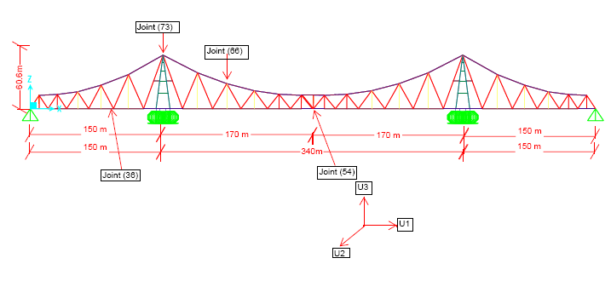

Fig.3:Schematic representation of the static deflection due to the half bridge own weight (western span ) .

Western Span

Eastern Span

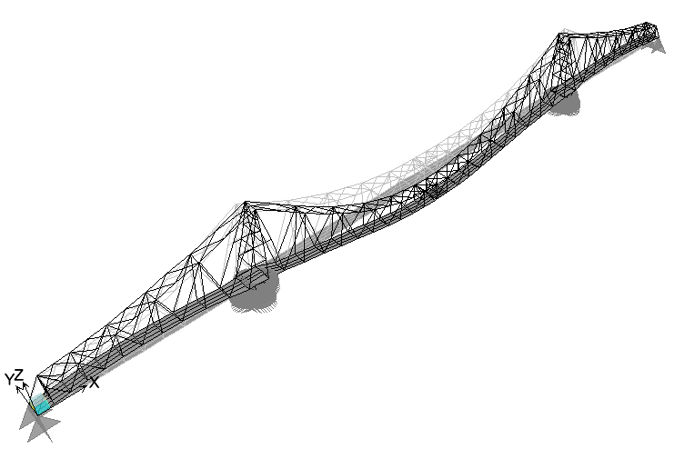Fig.1: Schematic representation of the bridge.

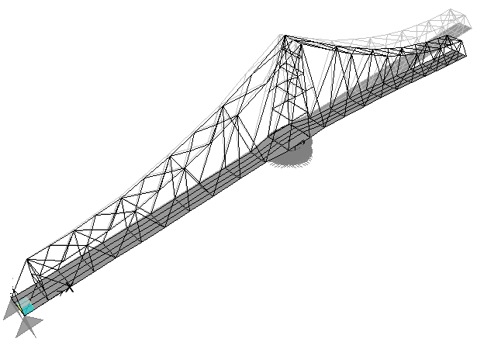Fig.2: Schematic representation of the static deflection due to the bridge own weight

Fig. 3: Schematic representation of the static deflection due to the half bridge own weigh (western span).



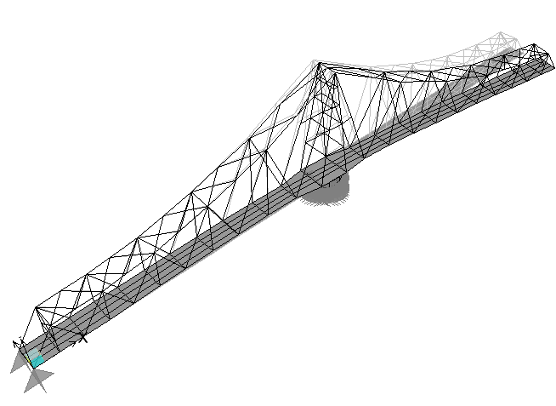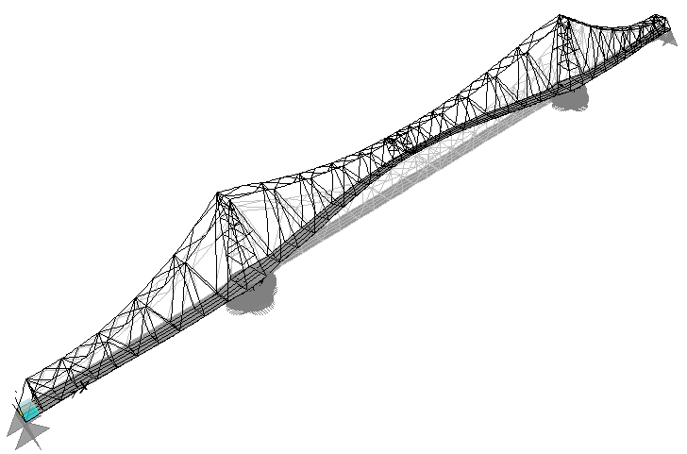

**Mode (1)**

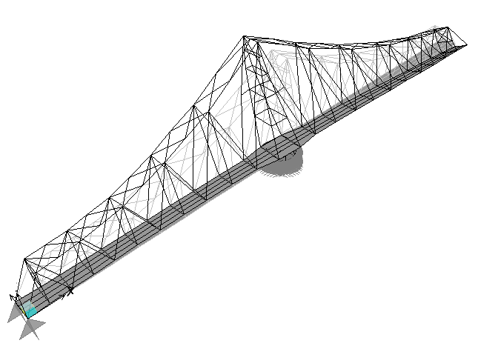

**Mode (2)**

**Mode (1)**

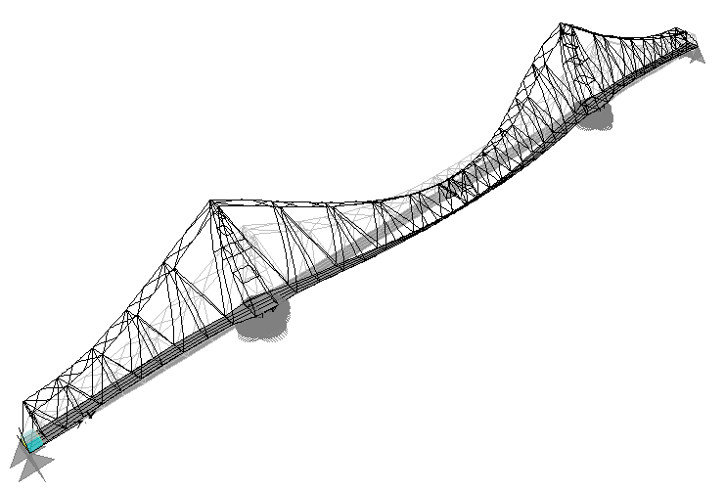

**Fig.4 : Lowest 10 Mode Shapes**

**Fig.5 : Lowest 10 Mode Shapes of half bridge**

**Mode (2)**

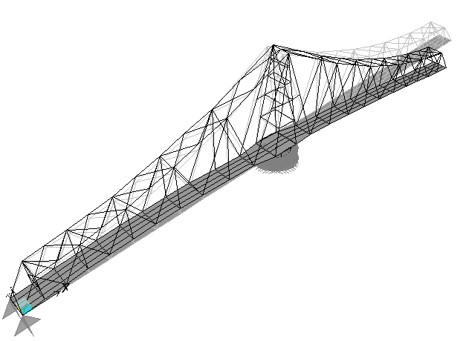

**Mode (3)**

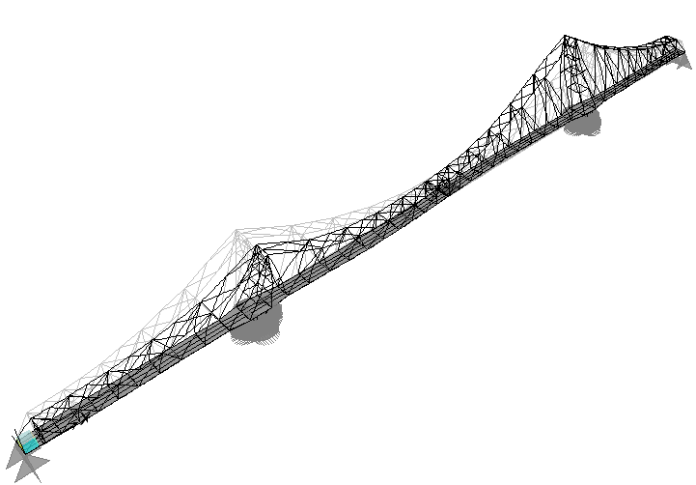

**Mode (3)**

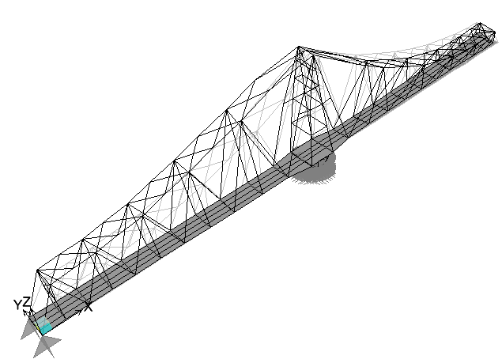

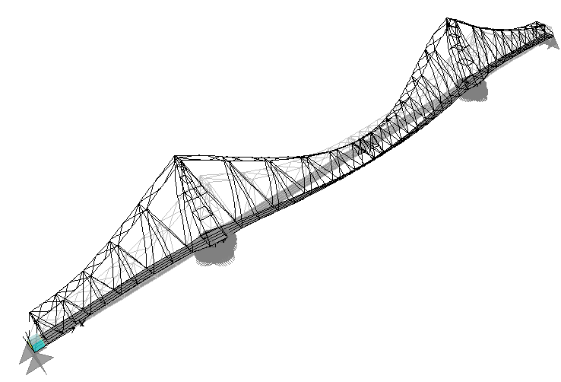

**Mode (4)**

**Mode (4)**

b

a

Fig.4: Lowest 4 Mode Shapes of a)Closed Bridge b)Open Bridge Western span





Displacement (m)



Displacement (m)



Displacement (m)

Fig.5: Displacement Time histories in longitudinal (U1), lateral (U2) and vertical (U3) directions for closed positions case.



Displacement (m)



Displacement (m)



Displacement (m)

Fig.6: Displacement Time histories in longitudinal (U1), lateral (U2) and vertical (U3) directions for open position case.



Spectral Acceleration



Spectral Acceleration



Spectral Acceleration

Fig.7: Spectral Acceleration VS period in lateral (U2) and vertical (U3) directions for closed position case.



Spectral Acceleration



Spectral Acceleration



Spectral Acceleration

Fig.8: Spectral Acceleration VS period in lateral (U2) and vertical (U3) directions for open position case.